*National Pesticide Safety Education Center*

**Back to the Future – Using Mass Media for Extension Messaging**

**Webinar Description:** Is the Extension system using the most modern and effective platforms and strategies to distribute content? How can extension reach new and untapped audiences? Mass Media used as an integrated system may provide a highly effective way to distribute content, reach new audiences and impact a broader range of demographics. But doing this requires working within two very different cultures and mindsets that will require a new thought process for extension professionals and a change in at least some of the bureaucratic structure and risk aversion commonly found in higher education. This has the potential to lead to a new paradigm shift for extension and opens an opportunity to reach and impact millions of new audience members. This webinar will share information about a pilot project led by the National Pesticide Safety Information Center (NPSEC) with partial support from the eXtension Foundation through the USDA New Technologies for Agricultural Extension grant.

**Presenters and their Roles:**

Tom Smith, Executive Director – The Big Picture

Courtney Weatherbee, Executive Assistant – The Organizational Challenges

Kara Maddox, Creative Director, Communications – Crafting the Creative Content

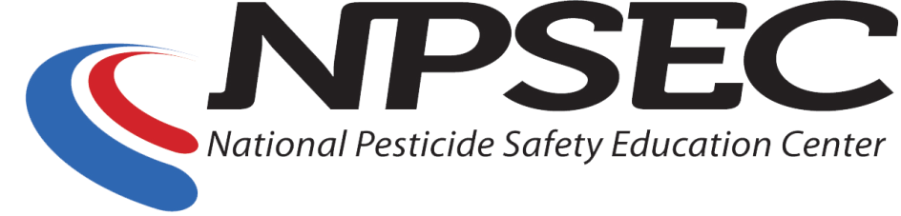

**Webinar Outline:**

1. Introductions & Background
2. What do we mean by mass media?
   1. Integrating Old (Radio) and New (Digital)
3. How does extension currently distribute content?
   1. Bulletins, fact sheets, manuals, many of which are now downloadable
   2. In person training at conferences and field days
   3. Webinars
   4. Mass Media
      1. Digital - Websites, Social Media (Facebook, Twitter, Instagram)
      2. Podcasts
      3. Radio (Farm Bureau, Ag Radio, other channels)
4. Often this is not a fully ‘Integrated Campaign’ or may not be integrated at all
5. But who are our audiences?
   1. i.e.) How do Millennials consume content?

1. **Here is the Value Proposition:** ***Mass Media used as an integrated system may provide a highly effective way to distribute content, reach new audiences and impact a broader range of demographics.***
   1. Extension has more scientific-based content than any other organization, yet does not typically use a modern strategy to distribute that content
   2. Radio and digital platforms are rapidly expanding and providers are looking for fact-based content to populate their channels
   3. Traditional extension content is not well suited to mass media – 30 seconds, 280 characters, highly visual, strategic – NPSEC can help extension transform their content into more consumable modalities to reach larger audiences not yet tapped by extension
2. How do we make the paradigm shift?
   1. ***The business model***
   2. ***The organizational challenges***
   3. ***The creative process***